Hi Sunny –

For this next project, I would like to try and recreate the following amcharts example: https://www.amcharts.com/demos/multi-part-gauge/

For our version, however, I’d like to reduce the size down to only 3 data series. I noticed in the example code that it’s possible to set the start and end angles of each of the graphed series, so I believe we can reduce the current example by 1 and then set the start and end angles to result in a final shape we desire.

As for the actual shape… can we ideally aim for one of the following…

Option 1

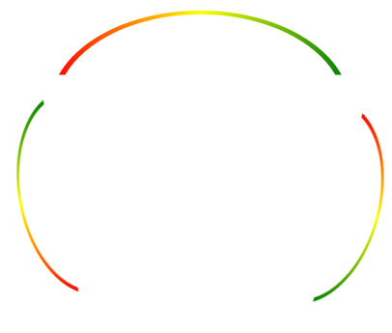

Option 2

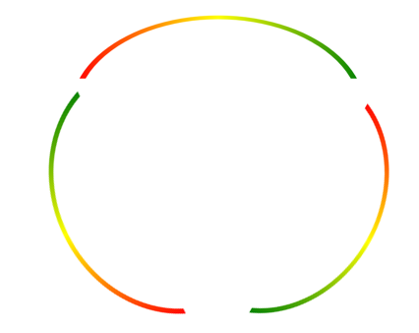

I don’t know which of the two options above I actually prefer… but the first is meant to be essentially be the same as the current amcharts example, with one graphed section removed and the remaining three rotated so that the middle one is centered.

The second example would be where each of the three is stretched a bit so that they form almost a complete circle.

Data series to be graphed…

We can use the data sourced for our existing three gauges for this single consolidated gauge chart.

Of the three semi circle graphs within the chart… my preferace would be for:

* The left semi-circle to be the PnL gauge
* The middle semi-circle to be the Sharpe Ratio gauge
* The Right semi-circle to be the volatility gauge

I remember that our individual gauge charts each dynamically set the min, max and middle values. Can that same process be extended to this new chart as well?

Color gradient…

Can the green to red fading dynamic that exists in the following amcharts example be extended to work with this gauge as well?

<https://www.amcharts.com/demos/gauge-with-gradient-fill/>

Labels…

Lets not use any labels for now on this chart… we will add some later but I’d like to brainstorm more on where the best placement will be. For now, can we only use standard tick marks similar in format to the existing example (e.g., 10%, 20%, etc)?